Computer Shop System

Use-Case Specification: Order Product

Version 1.0

Revision History

|  |  |  |  |
| --- | --- | --- | --- |
| **Date** | **Version** | **Description** | **Author** |
| 5/12/2019 | 1.0 | details | Hoang Trung Hieu |
|  |  |  |  |
|  |  |  |  |
|  |  |  |  |

Table of Contents

1. Use-Case Name 3

1.1 Brief Description 3

2. Flow of Events 3

2.1 Basic Flow 3

2.2 Alternative Flows 3

2.2.1 < First Alternative Flow > 3

2.2.2 < Second Alternative Flow > 3

3. Special Requirements 3

3.1 < First Special Requirement > 3

4. Preconditions 3

4.1 < Precondition One > 3

5. Postconditions 3

5.1 < Postcondition One > 3

6. Extension Points 3

6.1 <Name of Extension Point> 3

Use-Case Specification: Order Product

# Use-Case Name

## Brief Description

This use case defines the step of ordering computers. Customer can easily order computers by clicking the order button and fill in the order form.

# Flow of Events

## Basic Flow

Customer clicks the image of the desired computer. The system goes to the page which contains detailed information of that computer

* + 1. **Ordering one Computer at a time**

On the detailed information page of the computer, customer clicks the order button. The system goes to the computer order page. On that page, customer fills in the order form. Eventually, customer clicks the order sending button to send that order to computer shop.

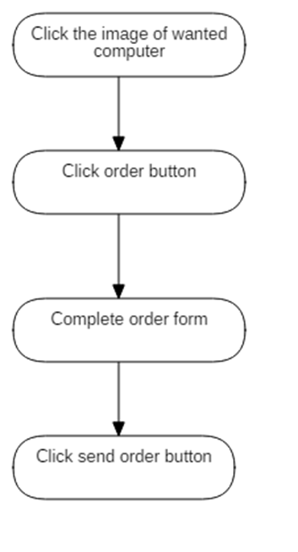

***Basic flow of ordering one computer at a time***

#### **Ordering More Than one computer at a time**

On the detailed information page of the computer, customer clicks the add to shopping cart button. A box informing the state of customer’s shopping cart is displayed. There are two options inside this box: continue shopping or order computer. To add more computers to shopping cart, customer clicks continue shopping button and follow the steps mentioned above. On the other hand, customer clicks order button inside that box to finish shopping and go to the computer order page. On this page, customer fills in the order form. Eventually, customer clicks order sending button to send that order to computer shop.

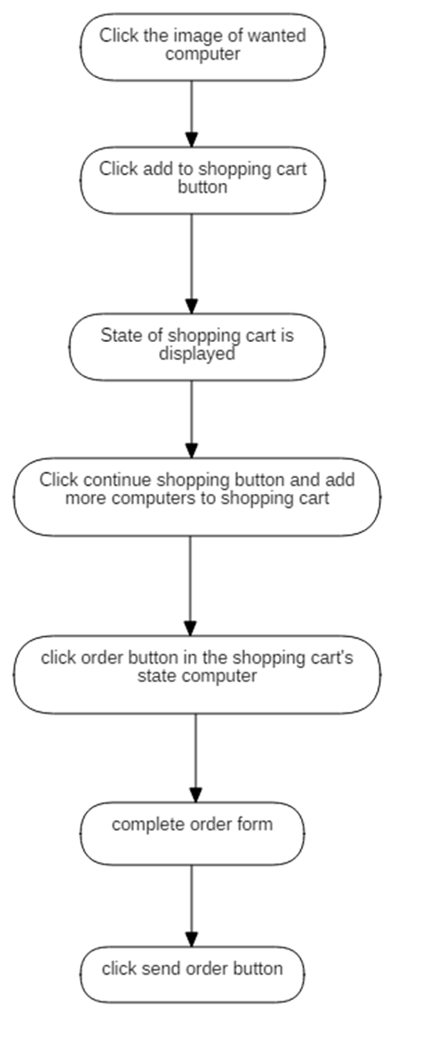

***Basic flow of ordering more than one computer at a time***

# Special Requirements

Accuracy is required when filling in the order form in order to save time and effort.

# Preconditions

No preconditions.

# Postconditions

No postconditions.

# Extension Points

Customer check the order again after having sent the order.